Helium MP3 Player

Brandon Jones, Giovanny Gorris, Aaron Ford and Nick Guillotte

Dept. of Electrical Engineering and Computer Science, University of Central Florida, Orlando, Florida, 32816-2450

Abstract — This paper outlines the design decisions of the development of a standalone music player. The project also encompasses a learning algorithm for identifying an individual’s listening habits based on weather and time of day. The learning algorithm is based some of the principles of Artificial Neural Networks and uses methods similar to “backprop” for training itself.

Index Terms — Band-pass filters, data transfer, digital audio players, network servers, radio communication, radio frequency identification.

I. Introduction
The original motivation for this project, Helium MP3 Player, was to develop a music playing system that required as little input from its users as possible. It was meant to monitor a room for people and play music at an appropriate volume for the conditions in the room (ie: if people were having a conversation, the volume would lower; if there was a large amount of noise, such as from a lawnmower, the volume would raise). It was meant to identify certain individuals “users” and play the music that they liked. The group decided that we would use Radio Frequency Identification (RFID) for the last goal. Current RFID technology proved to be inadequate for the task and the goals of the project have had to change quite a bit (for the worse) since then. This paper will identify what the final project will encompass.

The project consists of two devices: the primary device, for playing the music and implementing complex algorithms; and the secondary device, for identifying users.

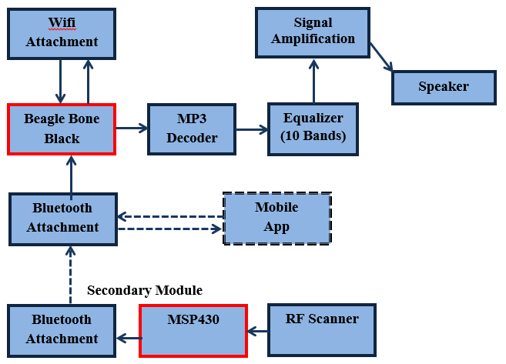

Fig. 1. Project Flowchart as is it designed. The MSP430 will receive the data through an RFID and then send it to the beagle bone black using Bluetooth device through UART.

The Primary Module is to be controlled by the Beagle Bone Black. The Secondary Module is controlled by the MSP430.
The Secondary Module consists of the MSP430 and an RF scanner. This module will be located at the entrance of the room. The Primary Module consists of the Beagle Bone Black, a Wi-Fi attachment, the MP3 Decoder, a ten band equalizer, an amplification stage and a speaker. This module will be located where ever the user wishes music to be played from.
The goal is for when a person walks into the room, where Helium is set up, the person will scan his or her tag on the RF Scanner. The RF Scanner will recognize the tag and send the identification of the tag to the MSP430. The MSP430 will then recognize who walked into the room based off of the frequency of the tag. The MSP430 will then send this information to the Bluetooth attachment so that the primary module’s Bluetooth attachment to receive the same information.
Once the Secondary Module attachment receives the information on who entered the room, this information will be sent to the Beagle Bone Black. From there the Beagle Bone Black will send music files to the MP3 Decoder. The MP3 Decoder will convert the digital signal to an analog signal (stereo). Then the signal will be converted to mono and sent through the ten band equalizer which is ten filters to control the frequencies of the song. After the equalizer the signal will go through an amplification stage so that the signal can be played through the speaker.

II. rfid System
As a way to send indicate to the MP3 player the presence of a user in the room, an RFID reader will be implemented on the project to scan tags identifying the user. Due to energy consumption that can arise by having an RFID scanning for tags, a passive RFID reader reading passive tags running at 13.56 MHz frequency will be used, but as a consequence the range is severely diminished.
As a method to program the RFID reader and be able to read different tags, the RFID will follow the standards set by ISO 14443A, ISO 14443B, ISO 15693, ISO 18000-3, and ISO 18092 that states how to design different types of smartcards. The RFID transceiver TRF7970a follows the requirement to accomplish this take
The method that will be used to control the RFID is through the SPI protocol of the MSP430 with the RFID reader acting as a slave and through the MSP430 receiving UART interface will receive the data inside the tag. Which will then be transfer to the beagle bone black to decipher which song to play based on the information within the tag.
To make sure that the RFID sends the information from the tag to the MSP430 a test was done to see if the standards are followed for the tags that are to be read, and the MSP430 inputs the data through UART which is then output through a console to see the results.
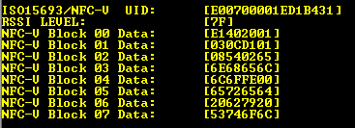

Fig 2. RFID test result with the data being sent to the MSP430 in which is sent to the console interface in hexadecimal.

A. Bluetooth/Wi-Fi

To make up for the short range of the RFID reader, it will not be attached to the main body of the project and will act as its own mobile system; this will allow for more convenient scanning without affecting the positioning of the main device. A Bluetooth device with UART capabilities will be implemented. The HC-06 Bluetooth module follows UART communication with a wake up pin which will allow the MSP430 to send the information without interfering with the RFID scanner.

 | HC-05 Bluetooth Module
Power Supply | 3.3 V
Power Scan | Low Power
Bluetooth Version | V2
Operating Temperature | -40°C to 85°C
Cost | $7.80

Table 1. Specifications of the HC-06 Bluetooth module.

Using the Bluetooth device will allow us to send the data as the beagle bone black will have another Bluetooth module to connect to. The MSP430 will act as a master module and will active when the data is ready to be sent to the beagle bone and will try to connect to it in which case the data is transferred to the board.
The Bluetooth on the primary module will also be able to communicate with the mobile app. The Bluetooth used is the KEDSUM® Arduino Wireless Bluetooth Transceiver slave Module. This will be connected to the primary module through UART and connected to the secondary module also through UART.
The Wi-Fi attachment will be connected into the USB of the Beagle Bone Black. The purpose of the Wi-Fi attachment would be to fetch information like weather, time and location if possible. Due to the Wi-Fi attachment the Beagle Bone Black needed to be powered by the 5V jack. It will also download the song from a server that will be stationed away from the beagle bone black.
B. Microcontroller
The RFID system requires a separate controller to control the RFID reader and the Bluetooth device. The secondary device will be spending most of its time idle, and so a lower power MCU will be used. An MSP430g2553 will be used as it is very low power.

C. PCB Board

The PCB is double layered and will hold the equalizer and the amplification stage. There is no need for the Bluetooth or Wi-Fi to be mounted because they can be connected directly to the pins on the beagle bone and the MSP430. The PCB board will included the design of the circuit as it is expected to look.

D. LCD Display

An LCD display will be used for the beagle bone black as a way to figure out the condition of the MP3 player. By using an LCD module, different messages can be displayed on screen as a case of troubleshooting or to display the information of the song being played or the information sent from the RFID reader through the MSP430. This would work great to see if the connection between the RFID works or not as the information inside the transponder can be displayed on-screen and then compare the result to the results given to Helium. It is also a good way to display images that fits with the song that is being played.

III. graphic equalization
The graphic equalizer is essentially comprised of several band-pass filters that are used to control a certain bandwidth of the signal coming from the audio file. The filter design uses two capacitors, each of which will be the same value, and selected based on the center frequency of the given filter. The gain is ideally unity gain, so that value will be set at 1. For each filter, the frequency, gain, Q-factor, and capacitance will be set, and the resistor values are then calculated. The equations for each resistor value are as follows. The input resistance, referred to as R1 in the reference design, is given by the equation:

R1 = $\frac{Q}{G*2πf*C}$ (1)

The attenuator resistance, referred to as R2 in the reference design, is given by the equation:

R2 = $\frac{Q}{\left(2Q^{2}-G\right)*2πf*C}$ (2)

The feedback resistance, referred to as R3 in the reference design, is given by the equation:

R3 = $\frac{Q}{πf*C}$ (3)

For each of the equations, G is the band pass gain, which has a value of 1. C is the capacitance represented by C1 and C2 in the reference design, which are set to the same value. Q is the Q-factor, and f is the center frequency. When determining which center frequencies to use, the idea is to cover the range from 20 Hz to 20 kHz without having any gaps in between the range of each band. The bandwidth of each filter is supposed to allow only a certain range of frequencies through while at full boost centered at a frequency. The relationship between center frequency, bandwidth, and Q is shown in the equation:

$Q=\frac{f_{0}}{∆f}$ =$\frac{f_{0}}{f_{2}-f_{1}}$, (4)
where $f_{0}$ is the center frequency, as shown in the figure above. By keeping a constant Q factor, and selecting the center frequency, the bandwidth can be solved for. However, the actual values of $f_{2}$ and $f_{1}$ are unknown. The values can be derived by observing the fact that the bandwidth is determined by the range formed after a 3 dB drop from maximum boost at the center frequency. The equations for $f_{1}$ and $f_{2}$ are as follows: the lower cutoff frequency, $f_{1}$, is
$f_{1}=f_{0}\left(\sqrt{1+\frac{1}{4Q^{2}}}-\frac{1}{2Q}\right),$ (5)
and the upper cutoff frequency, $f_{2}$, is
$f_{2}=f_{0}\left(\sqrt{1+\frac{1}{4Q^{2}}}+\frac{1}{2Q}\right).$ (6)
There is also a relationship between Q and bandwidth in octaves for each band on the equalizer. To evenly space each band on a 10 band equalizer, the bandwidths will be one octave apart, which means each center frequency doubles. This is ideal for the audible range because it is essentially 0-20 kHz, which means if you have 10 bands doubles each time, then that will cover all frequencies. Knowing that each band will be spaced one octave apart, the relationship between Q and octaves determines the Q-factor that is held constant to form the Constant-Q equalizer. The equation relating the two is:

$Q= \frac{\sqrt{2^{N}}}{2^{N}-1}$ , (7)

where N is the bandwidth in octaves. Since N has been determined to be 1, the equation yields Q = $\sqrt{2}$ $≈$ 1.41421. The industry standard values are 31, 63, 125, 250, 500, 1k, 2k, 4k, 8k, and 16 kHz. Each center frequency is doubled because of the octave and Q relationship. Using the equations presented in the paragraph above, these values can be proven to cover every frequency possible in the human audible range.
The equalizer’s design is separated into components for display purposes. Beginning with the input stage, the output from the VS1011 Decoder feeds into the equalizer circuit, is amplified, and inverted to fix the phase shift created by using the Multiple Feedback Band pass filters; show in Fig. 2.

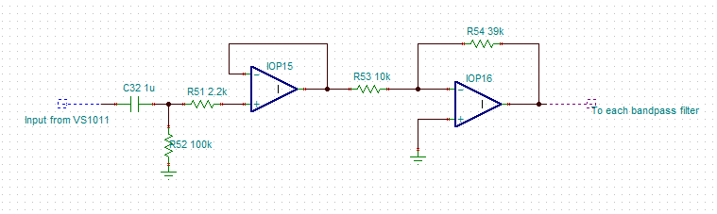
Fig. 3. Input from the mp3 decoder.
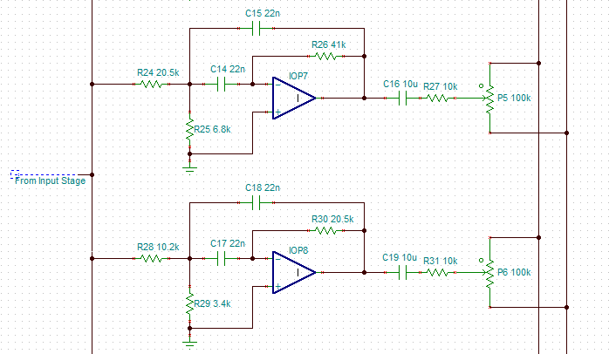
Fig. 4. Filter design for the equalizer. Two of the ten total bands are shown.
Next, the input stage feeds into the filter stage, which is represented by two of the ten iterations, shown in Fig. 4. The remaining filters have the same design, with different values built around the center frequency for each filter.
The output of each filter ultimately feeds into a 100 kΩ potentiometer. If the potentiometer is shifted towards the boost stage, then the boost circuit is activated, and positive gain is applied to the center frequency, Fig. 5.
The same applies, but vice versa for the cut stage, and a negative gain is applied to the center frequency. The cut stage is shown in Fig. 6.
Both the boost and cut stage feed into the output and the circuit is completed. The signal is now fed into an

amplifier and turned into the music we hear through the speaker (shown in Fig. 7).

Fig. 5. Boost or cut-off stage controlled by a 100 K potentiometer.

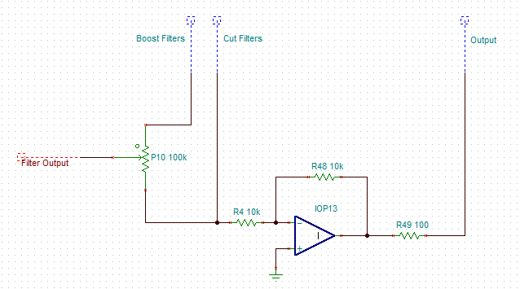

Fig. 6. Cutoff stage; if the potentiometer goes low then the signal will be reduced.

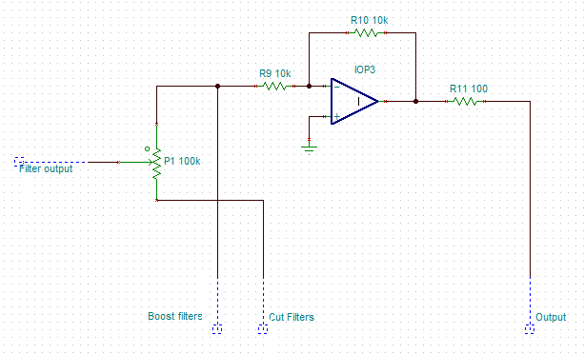

IV. audio
There were a few main components to consider when selecting a speaker for this system. First and foremost is to cover as much of the human audible frequency range as possible. The average human can pick up frequencies from 20 Hz to 20 kHz. It is very difficult to find a speaker that can produce sound at 20 Hz. Most speakers that can accomplish this have a very large power consumption and high cost, which does not work well with this system. There are many speakers that can get down to around 200 Hz on the low end of the frequency range. The speaker also needs to produce these sounds at a decent volume. So, there are four major components that were taken into consideration for selection. Frequency range, power, volume, and cost. A 1.5” in diameter speaker from Peerless was chosen. The specifications of the speaker chosen include a 200 Hz – 20 kHz frequency range, a 5 W maximum power allotment, 80.1 dB volume rating, and a cost of only $9.75.

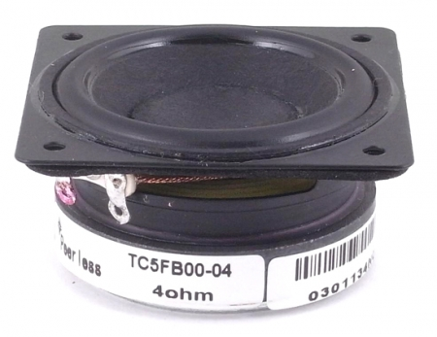

Fig. 7. Speaker that will be used to hear the sound from the beagle bone black.
A. MP3 Codec

In order for Helium to be able to play .mp3 files, it will need to be able to decode them. These files can either be decoded using software or hardware. Since the group’s software workload is already somewhat disproportionate to the group make up (3 EEs and 1 CpE), the group will use a hardware device for decoding the .mp3 files.

The company, VLSI solutions offers many ICs with the ability to both decode and encode MP3 files, as well as audio in many other formats. A few of their ICs are compared below.

V. Power

The Secondary module will be powered by a battery. A 3.7V, 2A Lithium Ion battery be power the Bluetooth and the MSP430. Since the scanner is a booster pack, the scanner will rest on top of the MSP430.
The Primary Module will be powered by the 5V jack. This will be plugged into the wall. The Wi-Fi will be plugged in through the Beagle Bone Black USB so that is where the power for the Wi-Fi will come from. The op amps in the Equalizer, the potentiometers, and the op amps in the amplification stage will be powered also through the Beagle Bone Black. The Beagle Bone Black has a power output of 5V. Using voltage regulators the needed power will be supplied to the equalizer stage and the amplification stage. The voltage and current needed by each device is shown in Table 2.

 | Voltage | Current
Beagle Bone  Black | 5V | 2A
Bluetooth | 3.3V | 8mA
Wi-Fi | Through USB
Op Amps | 18V
Digital Potentiometer | 1.8V to 5.5V
Scanner | Through MSB430
MSP430 | 3.7V | 2A

Table 2. Voltage and current needed for each device.

VI. SOFTWARE

Most of the software on the BBB will be written in Java. While the Mobile app and the content server will both be written, primarily in Python. The reason for this is that it is much quicker to develop in Python than in Java; the mobile app and server needed to be developed rapidly due to a lack of foresight when initially planning the project. The secondary device will be coded in C and C++ (because it doesn’t have to do very much).

A. Primary Device
The class diagram, in Fig. 8, shows an overview of the classes which will be running on the primary device. The program’s main loop will be ran from the Init class. Init will be responsible for coordinating data flow between the device’s three two control modules: DeviceController, and Communication; each of which will be ran in their own thread. The tasks for the
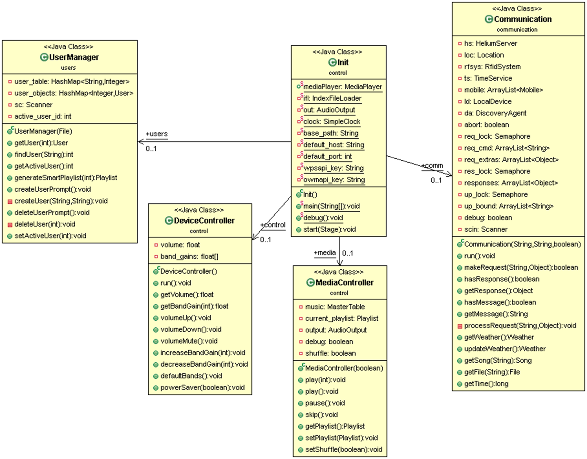
Fig. 8 A UML Class Diagram for the software on the primary device.
MediaController and UserManagement modules will be ran as part of the main thread.
The primary device will make use of several additional libraries made available by Apache: commons-logging (for use with other libraries), httpclient-4.1.2, httpcore-4.3.2, and json-20140107.

B. Mobile App
The mobile app will be allow for more in depth control of the primary device; such as selecting particular songs and playlists to play and other media playback functions. It will also allow for users to register and to upload their own songs to the BBB and to the content server.
The app will make use of the jQuery Mobile Framework and the Phonegap plugin for development of the GUI and control.
C. Content Server
The content server will act as a custom made database. It was developed using low level socket programming techniques.
In addition to allowing for the back and forth transfer of mp3 files, it will also carry out the transfer of: various user data, including listening habits and provide the time to the BBB (in the event that the NIST Internet Time Servers can’t be reached).
For file transfer, a custom made file transfer protocol was developed; similar to FTP, this protocol uses two connections: one for control and one for data transfer. This protocol will use only a single connection for transferring small amounts of highly structured data.
D. Additional Servers and Services
The BBB will need also be able to query a time server (NIST ITSs) and a weather server (Open Weather Map - OWM). In order to query the weather server, GPS coordinates are required; these will be obtained using WiFi Positioning Services (WPS) profided by Skyook [1]. A Java class implementing the OWM API was obtained (under the Apache License V 2.0) and simplified for use with the project.
E. Advanced Algorithms
The reason that the device keeps track of time and weather is for use in a “smart” algorithm for automatically generating playlists for users. These smart playlists will chose songs to play for a user based on the weather conditions and time of day. A total of 27 weather and time based conditions will be tracked by the device.
The project will keep track of what songs users listen to as well as the time and weather conditions when each song is listened to. Users will be able to apply tags to their songs; such as its genre and things like “female vocalist” or “punk influences”. By tagging their songs and listening to them using the device (or the standalone mobile player), an algorithm will attempt to identify tags (and individual songs) that tend to be played during certain weather and daylight conditions. This algorithm will use a simple Neural Network to learn these listening habits.
After the user listens to music for a sufficient period of time using the device or mobile music player, the device will be able to generate smart playlists for the user. And, eventually, will learn to start playing these during certain conditions when the user enters the room (and their RFID tag is scanned).
F. Testing the Algorithm
We predict that the smart song selection algorithm will require a large amount of data to be collected on a user before decent suggestions can be made. We won’t be able to collect this data naturally in a timely manner; to circumvent this issue, data will be fabricated for a test user. This user, “test user” will have strictly defined listening habits: test user listens to songs with female vocalists equally as often as songs with male vocalists; test user likes listening to “artsy” songs at night, when it is raining, and when it is very windy and very cloudy. We will then simulate the various conditions mentioned above and observe the songs suggested.

VII. CONCLUSION

The project, Helium MP3 Player allows for a highly customizable listening experience with its built in 10-band graphic equalizer and its tagging capabilities. The learning algorithm developed for this project is one step in the process of removing the need for user input when listening to experience. Radio Frequency Identification does not yet offer the desired read distance for it to be used practically for user identification in a large room. A more practical alternative might have been optical, or perhaps even voice-based, identification.

VIII. REFERENCES
[1]"Skyhook | Global Location and Context Software Products." Skyhook | Global Location and Context Software Products. N.p., n.d. Web. 10 Apr. 2015.

